**Task 1: Open SSIM**

**Task 2: Import the excel (titanic3.xls) to Adventure Database(sample db)**

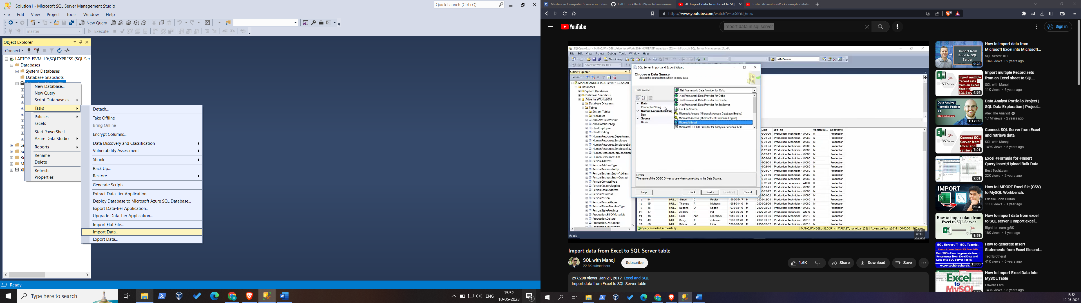

**Task 3: Data base imported**

